AIMS AND OBJECTIVES

Service Name: Kidsize Kingswells OOSC

Address: Kingswells Community Centre, Kingswells Avenue, AB158TG

Organisation/Provider: Kingswells Out of School Club is provided by Kidsize Club Ltd., a private company that provides Out of School Care to Primary School Children. Kidsize Club Ltd. was founded in 2018 by the company director Corinne Millar. Corinne also owns a sister company Kidsize Ltd. which provides activity clubs and events across Aberdeen City - including activity clubs at Kingswells and Altens Community Centres.

Kidsize Club Ltd. currently provides:
- Out of school club in Kingswells Community Centre CS2018368265
- Out of school club in Kingswells Primary School CS2018368265

Kidsize Club Ltd. is registered with Companies House SC601059

Description of Service:

Kingswells Out of School Club is registered to provide Out of School Care to primary school aged children, and drop off and collection to/from Kingswells Primary School. The service provides wraparound care to 73 children before school and after school across the two venues. We have use of the GP rooms within the school and are fully accessible allowing us to accommodate wheelchair users or others with disabilities.

Breakfast Club runs from 7:30am-9am Monday - Friday with drop off to Kingswells Primary School. After School club runs from 3:15pm-6pm with collection from Kingswells Primary School at 3:15pm. Inservice day sessions run from 8am-5pm on Aberdeen City inservice days.

Details of costs for sessions are available on our website and in our handbook. Costs are updated annually in April. We supported the use of tax free childcare vouchers as means of payment.

Staff Team:
Manager: Jenna Millar
Depute: Belle Rose
Staff Team: 2 Lead Practitioners and 6 + Playworkers
Staff:Child ratio of 1:10 will be maintained at all times during breakfast and after school club, and 1:8 during inservice day sessions when children are present over 5 hours.

Aims of the Service:

At Kidsize we put kids first: we believe in making friends, having fun, and learning more!
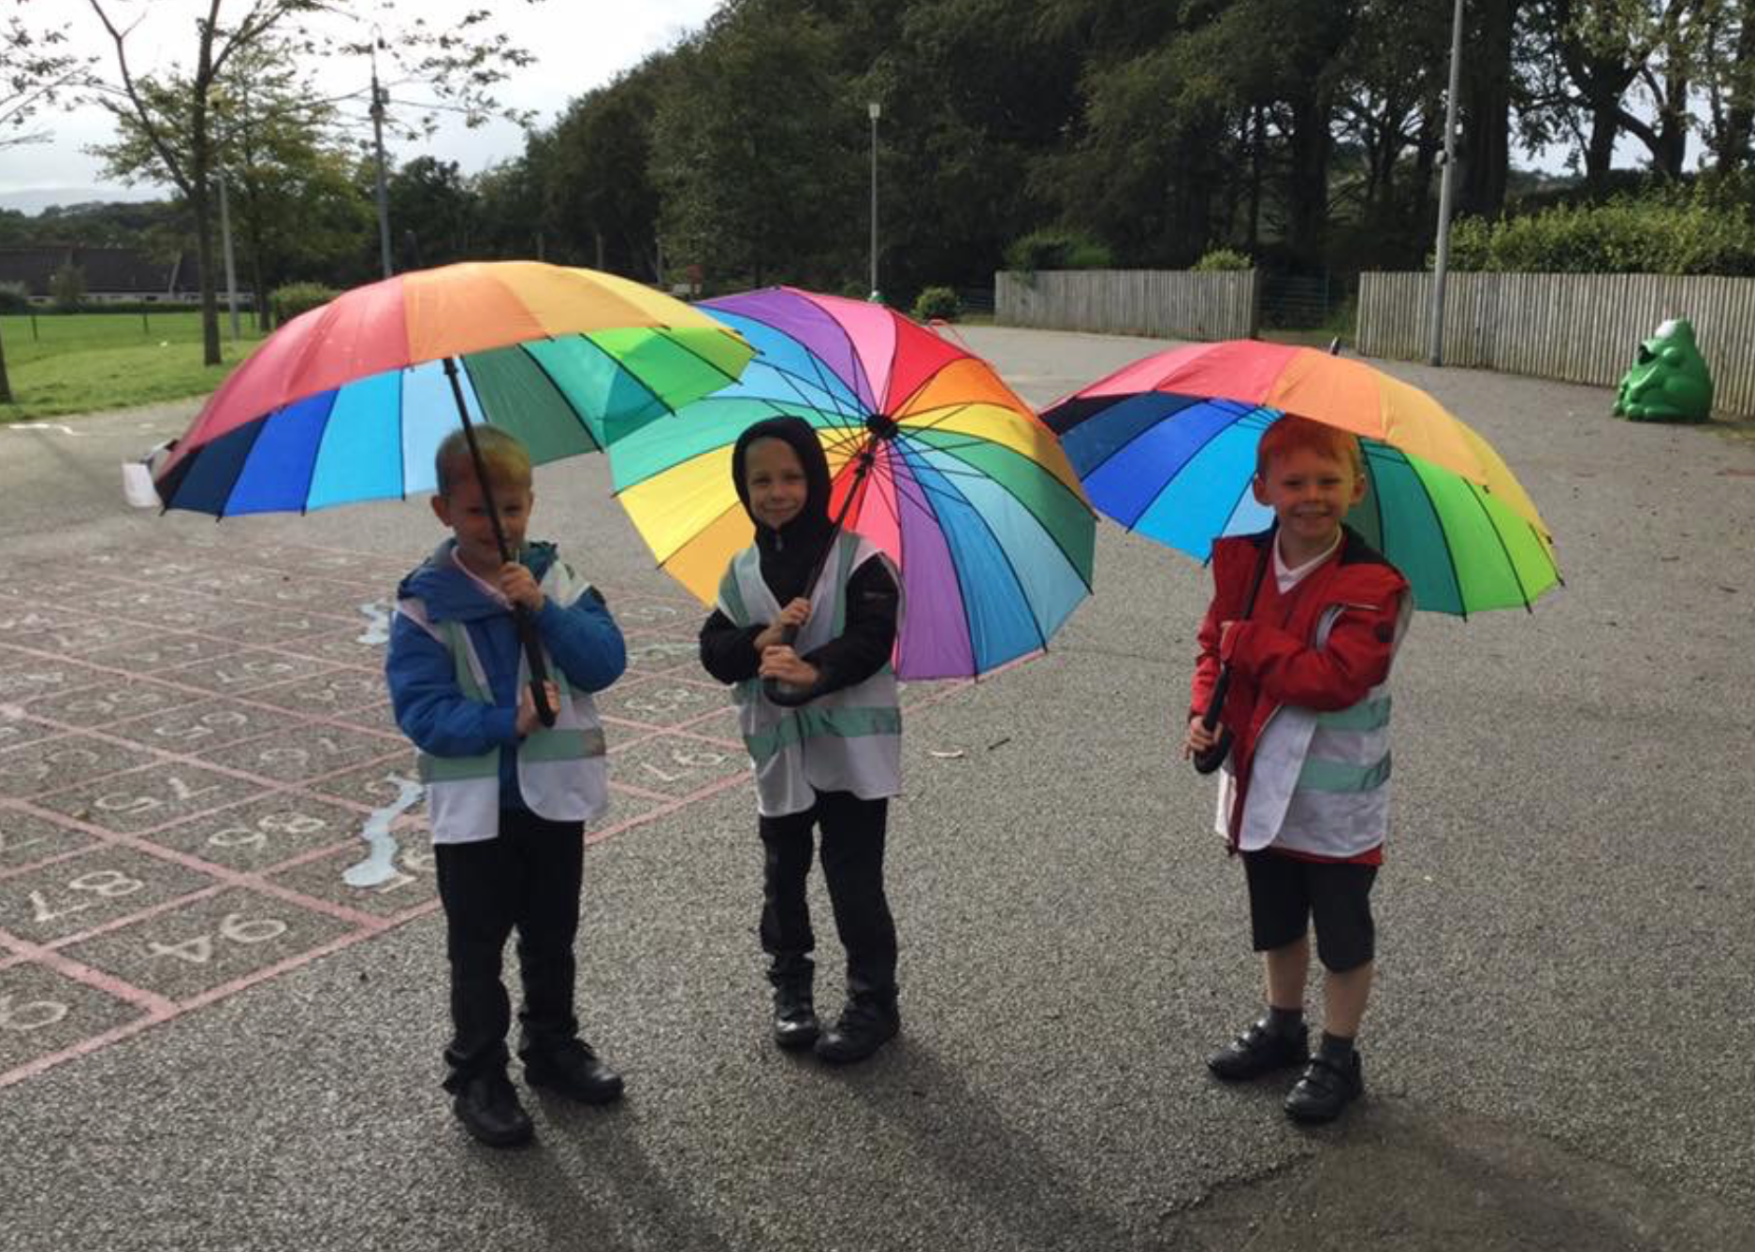
​
MAKING FRIENDS
We encourage all of our Kidsizers to create friendships with each other.
So far we have seen so many friendships blossom at Kidsize between friends
of different ages and genders who may otherwise not have the opportunity
to become friends at school. We are proud of the inclusive environment
that exists at Kidsize, nobody is ever left out of play or group work.
These friendships form organically through the activities we organise.
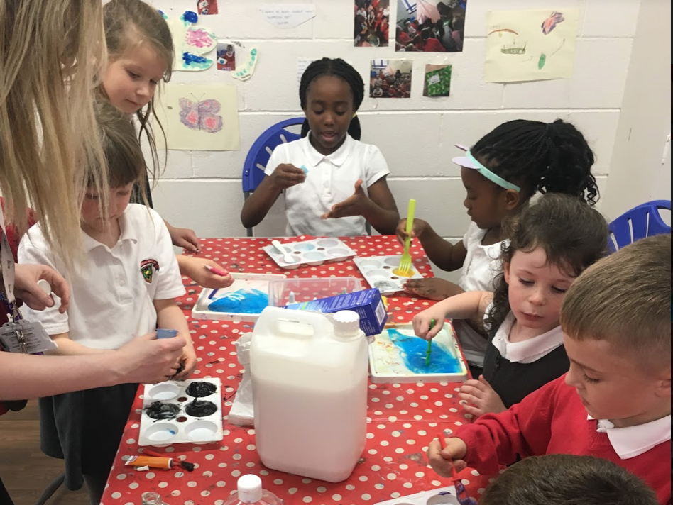
HAVING FUN
Our main aim for our Out of School Club is to ensure that the children are having as much fun as possible. To do this we provide a large selection of play opportunities that will stimulate and challenge children. By providing several play types we are ensuring that every child has a chance to join in with an activity they not only enjoy but often excel in. We promote child centred working by ensuring children are given choices and that they are heard and valued. The children who attend our club help to plan termly topics and can even lead group activities if they wish.
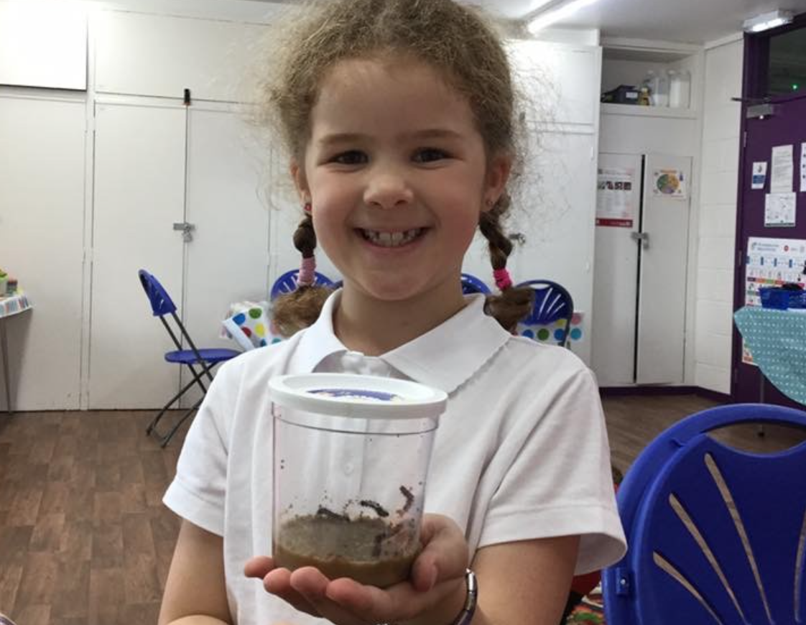
LEARNING MORE
At Kidsize we recognise and value the importance of learning through play.
We believe that through every activity there is an opportunity to learn and develop. Kidsize organises stimulating and inspiring activities for children to gain new skills and knowledge. Through science experiments; designing and creating; writing scripts and performing; and outdoor activities, the children are always engaging in active learning throughout their time at Kidsize. We also create a safe and secure environment for children to develop and build on their social skills.

At Kidsize Club Ltd. we believe in the importance of play. Play encourages social interaction between varying age groups as well as increased social skills.

At Kidsize we follow the Playwork Principles:
- All children and young people need to play. The impulse to play is innate. Play is a biological, psychological and social necessity, and is fundamental to the healthy development and well-being of individuals and communities.
- Play is a process that is freely chosen, personally directed and intrinsically motivated. That is, children and young people determine and control the content and intent of their play, by following their own instincts, ideas and interests, in their own way for their own reasons.
- The prime focus and essence of playwork is to support and facilitate the play process and this should inform the development of play policy, strategy, training and education.
- For playworkers, the play process takes precedence and playworkers act as advocates for play when engaging with adult led agendas.
- The role of the playworker is to support all children and young people in the creation of a space in which they can play.
- The playworker's response to children and young people playing is based on a sound up to date knowledge of the play process, and reflective practice.
- Playworkers recognise their own impact on the play space and also the impact of children and young people’s play on the playworker.
- Playworkers choose an intervention style that enables children and young people to extend their play. All playworker intervention must balance risk with the developmental benefit and well-being
- of children.
(Playwork Principles Scrutiny Group, 2005)

We also aim to continuously improve the setting and consult children and parents/carers in the improvement and development process.

Kidsize Out of School Club aims to provide healthy and nutritious breakfast and snack options and ensure children are involved in the choosing and preparation.

We do this by meeting GIRFEC, Playwork Principles, UNCRC and Health and Social Care Standards: My Life, My Support.

Objectives: Meeting the Health and Social Care principles and standards: My Support, My Life

At Kidsize we work in line with the Health and Social Care principles and standards: My Support, My Life to provide best practice.

Standard 1: I experience high quality care and support that is right for me
We provide high quality care and support to children that is right for them by ensuring their personal plans are kept up to date and meet the children’s needs. These are reviewed every 6 months to ensure children are receiving the care they require. Children and parents are involved in the development of personal plans. Staff complete regular child observations to contribute towards the child’s personal plans.

We follow our Equal Opportunities Policy to ensure children are respected and protected against discrimination.

Children can exercise their right to play by engaging in various play opportunities that they choose. They are given a choice of play inside or outside. Physical play outdoors helps the child to become fit and healthy. We also promote good health by offering nutritious snack and breakfast options.

Standard 2: I am fully involved in all decisions about my care and support
We follow a Child Participation Policy to ensure children’s voices are heard and that they are able to make decisions surrounding their care. They are involved in choosing termly topics and activities, deciding what play opportunities should be provided and getting involved in the development of their personal plans. Children also participate in choosing the snack menu.

We also have a Working in Partnership with Parents Policy to ensure parents/carers are involved in the development of the setting and the care of their child. Meetings with parents/carers will be held for those who require more support. Parents are regularly kept up to date via email and with posts on social media. We send out feedback forms to gauge how they feel about the service we provide.

Standard 3: I have confidence in the people who support and care for me
We aim to have at least 50% of our WTE staff force hold or work towards a relevant qualification. Staff are required to complete a minimum of 5 hours of Continuous Professional Development per term and have termly appraisal meetings with the manager of the setting. Regular team meetings are held where best practice is fed back to staff.

Staff are recruited in line with Safe Recruitment practices and must be PVG checked before starting within the setting. All staff are registered with SSSC within 6 months of starting.

Standard 4: I have confidence in the organisation proving my care and support
The organisation follows best practice issued by the Care Inspectorate. Quality Assurance is undertaken to ensure we are providing the best service possible and we are continuously improving the setting. Policies and procedures are updated annually so ensure we are staying in line with current best practice. We stay in touch with the Care Inspectorate and complete the relevant eForms when required.

Standard 5: I experience a high-quality environment if the organisation provides the premises
We work in partnership with the Community Centre manager to ensure that the Centre is kept the the highest standard. We regularly clean the setting to ensure a clean and tidy setting. Staff follow the correct Health and Safety procedures to ensure the premises is hazard free and safe for the children to play. Risk assessments are completed and reviewed regularly. New equipment for the setting is purchased regularly and any broken equipment is either fixed or thrown away.

If any service users believe we are not meeting these standards to a high quality they can exercise their right to make a complaint by following our complaints procedure or contacting the Care Inspectorate directly.

Created: 01/10/2022 By: Jenna Millar
Reviewed: 15/09/2023 By: Jenna Millar

